1. Which list contains only scalar quantities?

A mass, acceleration, temperature, kinetic energy
B mass, volume, electric potential, kinetic energy
C acceleration, temperature, volume, electric charge
D kinetic energy, velocity, length, electric potential

2. If p is the momentum of an object of mass m, the expression 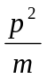 has base units identical to
A energy. C power.
B force. D velocity.

3. Forces of 4 N and 6 N act at a point. Which one of the following could not be the magnitude of their resultant?

A 1 N C 8 N
B 4 N D 10 N

4. A student uses vernier callipers to measure the sides of rectangular wafer of silicon to the nearest tenth of a millimetre. The lengths are 10.4 mm, 6.3 mm and 2.3 mm.
Which of the following best expresses the volume of the wafer?

A 1.50696 × 10² mm³
B 1.5 × 10² mm³
C 1.507 × 10² mm³
D 1.51 × 10² mm³

5. A body, dropped from a tower, is timed to take (2.0 0.1) s to fall to the ground. If the acceleration of free fall is taken as 10 ms⁻², the calculated height of the tower should be quoted as

A (20.0 0.2) m C (20 1) m
B (20.0 0.5) m D (20 2) m

6. When comparing systematic and random errors, the following pairs of properties of errors in an experimental measurement may be contrasted:
P₁ : error can possibly be eliminated
P₂ : error cannot possibly be eliminated
Q₁ : error is of constant sign and magnitude
Q₂ : error is of varying sign and magnitude
R₁ : error will be reduced by averaging repeated measurements
R₂ : error will not be reduced by averaging repeated measurements
Which properties apply to random errors?

A P₁, Q₁, R₂ C P₂, Q₁, R₂
B P₁, Q₂, R₁ D P₂, Q₂, R₁

7. A brick is dislodged from a tall building and falls vertically under gravity. Which one of the following curves represents the variation of its height h above the ground with time t if air resistance is negligible?
A 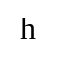 C

t t

B D

t t

h

8. A lunar landing module is descending to the Moon's surface at a steady velocity of 10 ms⁻¹. At a height of 120 m, a small object falls from its landing gear.
Taking the Moon's gravitational acceleration as 1.6 ms⁻², at what speed does the object strike the Moon?

A 30 ms⁻¹ C 20 ms⁻¹
B 22 ms⁻¹ D 17 ms⁻¹

9. A ball is projected horizontally from the top of a cliff on the surface of the Earth with a speed of 40 ms⁻¹. Assuming that there is no air resistance, what will its speed be 3 s later?

A 30 ms⁻¹ C 50 ms⁻¹
B 40 ms⁻¹ D 60 ms⁻¹
10. When a force of 4 N acts on a mass of 2 kg for a time of 2 s, what is the rate of change of momentum?

A 1 kgms⁻² C 4 kgms⁻²
B 2 kgms⁻² D 8 kgms⁻²

11. Three identical stationary discs, R, S and T are pieced in a line on a horizontal, flat, frictionless surface. Disc R is projected straight towards disc S.

R
S
T

If all consequent collisions are perfectly elastic, what will be the final motion of the three discs?

 | R | S | T
A | moving left | moving left | moving right
B | moving left | Stationary | moving right
C | moving left | moving right | moving right
D | stationary | Stationary | moving right

12. A mass accelerates uniformly when the resultant force acting on it

A is zero.
B is constant but not zero.
C increases uniformly with respect to time
D is proportional to the displacement of the mass from a fixed point.

- A small ball of weight W is suspended by a light thread. When a strong wind blows horizontally exerting a constant force F on the ball, the thread makes an angle θ to the vertical as shown in the diagram.

θ
W
F

Which of the following equations correctly relates θ, F and W?

A cos 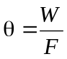 C tan 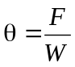

B sin D tan

14. A heavy uniform plank of length L is supported by forces F₁ and F₂ at points distant 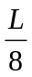and 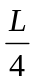 from the ends as shown in the diagram below.

L
L/4
L/8

Plank
F₁
F₂

What is the ratio of F₁ to F₂?

A 1 : 2 C 2 : 7
B 3 : 4 D 2 : 3

15. Two forces P and Q act at a point X as shown in the vector diagram below.

P
Q

X

In which of the following diagrams does the vector F represent the force which must be applied at X to maintain equilibrium?
P
P
F F

Q Q

Q P Q P
F

F
A
C

B
D

16. An electric motor is required to haul a cage of mass 400 kg up a mine shaft through a vertical height of 1200 m in 2.0 minutes. What will be the electrical power required the overall efficiency is 80%? [ Take g as 10 m s⁻² ]

A 3.2 kW C 32 kW
B 5.0 kW D 50 kW

17. A car of mass m has an engine which can deliver power P. What is the minimum time in which the car can be accelerated from rest to a speed v?

A 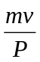 C 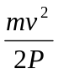

B 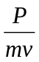 D 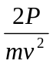

18. What is the power required to give a body of mass m a forward acceleration a when it is moving with velocity v up a frictionless track inclined at an angle θ to the horizontal?

A mavg sin θ C mav + mgv sin θ
B mav sin θ + mgv D ( mav + mgv ) sin θ

19. Given that the Earth is a sphere of mean radius 6.4 × 10⁶ m and of mass 6 × 10²⁴ kg, estimate the mean density of the Earth.

A 5.46 × 10³ kgm⁻³ C 2.29 × 10⁴ kgm⁻³
B 9.38 × 10¹⁷ kgm⁻³ D 1.07 × 10¹⁸ kgm⁻³

20. A long narrow tube contains salt water of density 1 020 kgm⁻³ to a depth of 1 m. The tube is then inclined at 30⁰ to the horizontal. If atmospheric pressure is 100 kPa, what is the pressure at the bottom of the tube?

A 105 kPa C 110 kPa
B 100 kPa D 1 020 kPa

21. A sound wave of amplitude 0.20 mm has an intensity of 3.0 Wm⁻².
What will be the intensity of a sound wave of the same frequency which has an amplitude of 0.40 mm?

A 4.2 Wm⁻² C 9.0 Wm⁻²
B 6.0 Wm⁻² D 12 Wm⁻²

22. The diagram below represents the intensity distribution produced on a screen by the diffraction of light.
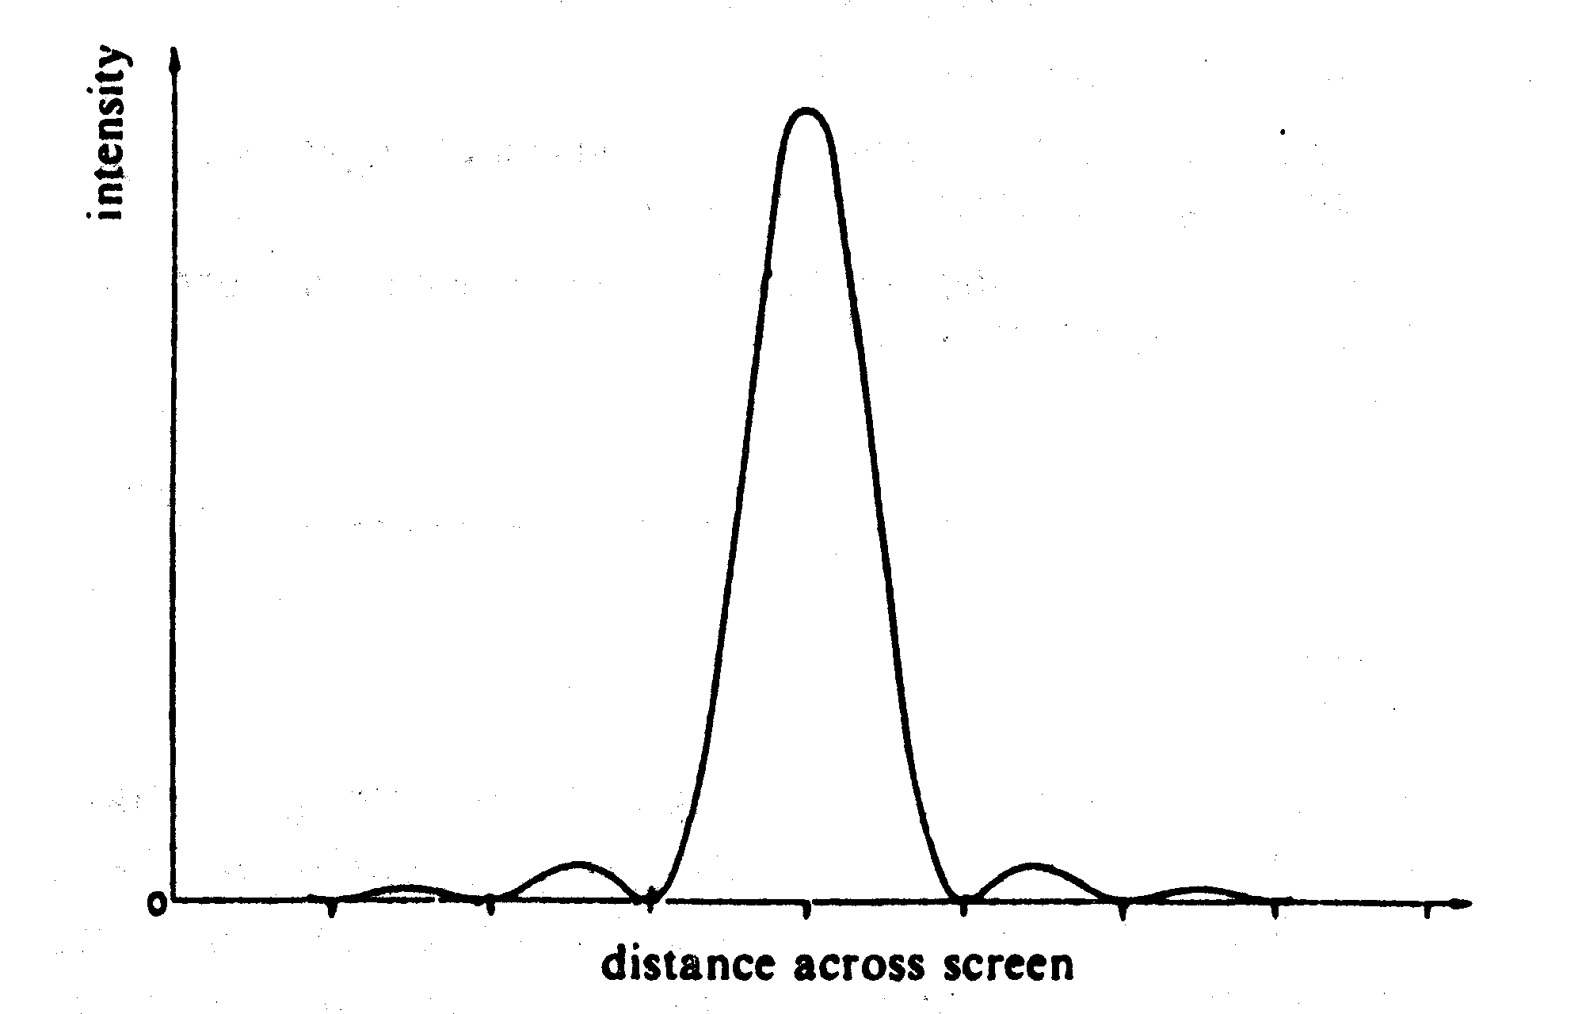

This can be achieved by using

- one single wavelength and a single slit.
- one single wavelength and a double slit
- two separate wavelength and a single slit.
- two separate wavelength and a double slit.

23. Light of wavelength λ is incident normally on a diffraction grating for which the slit spacing is equal to 3λ.
What is the sine of the angle between the second order maximum and the normal?

A  B C  D 1

24. When a two – slit arrangement was set up to produce interference fringes on a screen using a monochromatic source of green light, the fringes were found to be too close together for convenient observation. In which of the following ways would it be possible to increase the separation of the fringes?

A Decrease the distance between the screen and the slits
B Increase the distance between the source and the slits
C Have a larger distance between the two slits
D Replace the light source with a monochromatic source of red light

25. In the diagram below, T represents a transmitter of microwaves and P represents a metal plate.
P
detector
T

The detector is connected to a galvanometer. The distance TP is much greater than the wavelength of the microwaves.
As the detector is moved between T and P, what happens to the galvanometer reading?

A It decreases steadily.
B It reaches a maximum at P.
C It reaches a maximum midway between T and P.
D It increases and decreases regularly.

26. The diagram shows a transverse wave on a rope. The wave is traveling from left to right. At the instant shown, the point P and Q on the rope have zero displacement and maximum displacement respectively.

Q
P

Direction of wave

Which of the following describes the direction of motion, if any, of the points P and Q at this instant?

 | point P | point Q
A | downwards | stationary
B | stationary | downwards
C | stationary | upwards
D | upwards | stationary

27. Why does the current increase when the potential difference applied across a metallic conductor is increased?

A There is less chance of a charge striking an atom.
B The mean time between collisions decreases.
C The acceleration of the charge carriers between collisions increases.
D The rise in temperature increases the thermal motion of the charge carriers.

28. Two large horizontal metal plates are separated by 2 mm. The lower plate is at a potential of –6V.

- 6V
2 mm

What potential should be applied to the upper plate to create an electric field of strength 2000 Vm⁻¹ upwards in the space between the plates?

A +22 V C -10 V

B +10 V D -2 V

29. In the direction indicated by an electric field line,

A the electric field strength must increase
B the electric field strength must decrease
C the potential must increase
D the potential must decrease

30. A battery is connected in series with a 2 Ω resistor and a switch as shown in the figure below. A voltmeter connected across the battery reads 12 V when the switch is open but 8 V when it is closed.

2 Ω
What is the internal resistance of the battery?

A Ω B 1 Ω C  D 4 Ω
31. A rod is to be drawn from a 100 cm³ of metal of resistivity 1.76 10⁻⁸ Ωm. What is the cross sectional area of the rod if the resistance of the rod is to be 7.0 10⁻⁴Ω?

A 2.5 10⁻⁹ m² B 4.7 × 10⁻⁹ m²

C 5.0 10⁻⁵ m² D 6.3 10⁻⁵ m²

32. A constant voltage d.c. source is connected, as shown in the diagram below, across two resistors of resistance 400 kΩ and 100 kΩ.

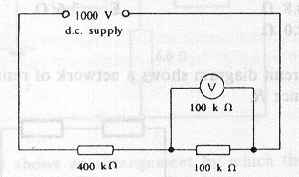

What is the reading of the voltmeter, also of resistance 100 kΩ, when connected across the second resistor as shown?

A 111 V B 125 V C 200 V D 250 V

33. Three similar light bulbs are connected to a constant – voltage d.c. supply as shown in the figure below. Each bulb operates at normal brightness and the ammeter (of negligible resistance) registers a steady current.
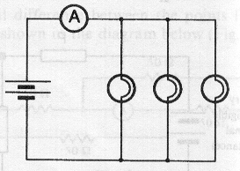

The filament of one of the bulbs breaks. What happens to the ammeters reading and to the brightness of the remaining bulbs?

 | ammeter reading | bulb brightness
A | increases | increases
B | increases | unchanged
C | unchanged | unchanged
D | decreases | unchanged

34. Three identical dry cells each having an e.m.f. of 1.5 V and a constant internal resistance of 0.5 Ω are connected in series with a 3.0 Ω resistor R, firstly in circuit (i), and secondly as in circuit (ii).

What is the ratio of the power dissipated in R in circuit (i) to that in circuit (ii)?

A 0.3 B 3.0 C 9.0 D 1.8

- Four resistors are connected as shown.
R
Q
P
S
1Ω
3Ω
4Ω
2Ω

Between which two points does the maximum resistance of the combination occur?

A P and Q
B Q and S
C R and S
D S and P

36. Which statement describes the electric potential difference between two points in a wire that carries a current?

A the force required to move a unit positive charge between the points
B the ration of the energy dissipated between the points to the currents
C the ration of the power dissipated between the points to the current
D the ration of the power dissipated between the points to the charge moved

37. A potential divider is used to give outputs of 2 V and 3 V from a 5 V source, as shown.
+2V
+3V

3R₂
0V
+ 5V
R₂
R₂
R₁

Which combination of resistances, R₁, R₂, R₃, gives the correct voltages?

 | R₁/kΩ | R₂/kΩ | R₃/kΩ
A | 1 | 1 | 2
B | 2 | 1 | 2
C | 3 | 2 | 2
D | 3 | 2 | 3

38. The nucleus of uranium (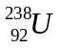) may undergo successive decays, emitting respectively an - particle, a  - particle and a - ray. The resulting nucleus may be represented by

A 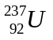 B 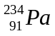

C 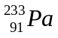 D 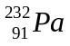

39. The isotope which decays by - emission to produce 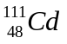 is

A 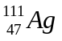 B 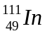

C 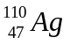 D 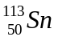

40. A thin gold foil is bombarded with α - particles as shown.

incident α - particles

gold foil

The result of this experiment provides information about the

A binding energy of a gold nucleus.
B energy levels of electrons in gold atoms
C size of a gold nucleus
D structure of a gold nucleus

